OPERATING AGREEMENT BETWEEN CALIFORNIA STATE UNIVERSITY
AND CALIFORNIA STATE UNIVERSITY, BAKERSFIELD

ASSOCIATED STUDENTS, INCORPORATED
Campus Operating Agreement (COA) 1468

This agreement is made and entered into by and between the Trustees of the California State University (CSU) and California State University, Bakersfield Associated Students, Incorporated (Auxiliary) serving California State University, Bakersfield (Campus). The term of this agreement shall be July 1, 2023 through June 30, 2030 unless sooner terminated as herein provided.

PURPOSE

The purpose of this agreement is to set forth the terms and conditions under which Auxiliary may operate as an auxiliary organization pursuant to California Education Code Section (§) 89900 et seq. and California Code of Regulations (CCR) Title 5, Section (§) 42400 et seq. In entering this agreement, CSU finds that certain functions important to its mission are more effectively accomplished by the use of an auxiliary organization rather than by the Campus under the usual state procedures.

PRIMARY FUNCTION(S) OF THE AUXILIARY

In consideration of receiving recognition as an official CSU auxiliary organization, Auxiliary agrees, for the period covered by this agreement, that the primary function(s), which the Auxiliary is to manage, operate or administer are:
[X]Student Body Organization [ ]Student Union
[ ]Housing
[ ]Philanthropic
[ ] Externally Funded Projects
[ ]Real Property Acquisition / Real Property Development [ ]Commercial
In carrying out the above, the Auxiliary engages in the following functions authorized by, CCR tit.5, §42500, which are activities essential and integral to the educational mission of the University:

Student Body Organization Programs and Services, which includes student government and leadership development, financial support for student programming and events;
Instructionally Related Programs and Activities;
Scholarships, grants-in-aids, stipends and related financial assistance.

Auxiliary agrees to receive and apply exclusively the funds and properties coming into its possession toward furthering these purposes for the benefit of CSU and the Campus.

Auxiliary further agrees that it shall not perform any of the functions listed in CCR tit.5,
§42500 unless the function has been specifically assigned in this operating agreement with the Campus. Prior to initiating any additional functions, Auxiliary understands and agrees that CSU and Auxiliary must amend this agreement in accordance with Section 21, Amendment.

CAMPUS OVERSIGHT AND OPERATIONAL REVIEW

The responsibility and authority of the Campus President regarding auxiliary organizations is set forth in CCR tit.5, §42402, which requires that auxiliary organizations operate in conformity with CSU and Campus policies. The Campus President has been delegated authority by the CSU Board of Trustees (Standing Orders
§VI) to carry out all necessary functions for the operation of the Campus. The operations and activities of Auxiliary under this agreement shall be integrated with Campus operations and policies and shall be overseen by the campus Chief Financial Officer (CFO) or designee so as to assure compliance with objectives stated in CCR tit.5,
§42401.

The Campus shall review Auxiliary to ensure that the written operating agreement is current and that the activities of Auxiliary are in compliance with this agreement at least every five (5) years from the date the operating agreement is executed and at least every five years thereafter. Confirmation that this review has been conducted will consist of either an updated operating agreement, or a letter from the Campus CFO or designee to the Campus President with a copy to the Chancellor’s Office, certifying that the review has been conducted. As part of these periodic reviews, the Campus President should examine the need for each auxiliary and look at the efficiency of the auxiliary operation and administration.

Auxiliary agrees to assist the Campus CFO or designee in carrying out the compliance and operational reviews required by applicable CSU Executive Orders and related policies.

OPERATIONAL COMPLIANCE
Auxiliary agrees to maintain and operate its organization in accordance with all applicable laws, regulations and CSU and Campus rules, regulations and policies. Failure of Auxiliary to comply with any term of this agreement may result in the removal, suspension or probation of Auxiliary as an auxiliary organization in good standing. Such action by CSU may result in the limitation or removal of Auxiliary's right to utilize the CSU or campus name, resources and facilities (CCR tit.5, §42406).

CONFLICT OF INTEREST
No officer or employee of the CSU shall be appointed or employed by Auxiliary if such appointment or employment would be incompatible, inconsistent or in conflict with his or her duties as a CSU officer or employee.

Auxiliary has established and will maintain a conflict of interest policy. The Auxiliary’s Conflict of Interest Policy is attached as Attachment 1.

EXPENDITURES AUGMENTING CSU APPROPRIATIONS

With respect to expenditures for public relations or other purposes which would serve to augment appropriations for CSU operations, Auxiliary may expend funds in such amount and for such purposes as are approved by Auxiliary's governing body. Auxiliary shall file, as Attachment 2 to this agreement, a statement of Auxiliary's policy on accumulation and use of public relations funds. The statement shall include the policy and procedures for solicitation of funds, the purposes for which the funds may be used, the allowable expenditures and procedures of control.

FISCAL AUDITS

Auxiliary agrees to comply with CSU policy and the provisions of CCR tit.5, §42408, regarding fiscal audits. All fiscal audits shall be conducted by auditors meeting the guidelines established the Integrated CSU Administrative Manual (ICSUAM).

The Campus CFO shall annually review, and submit a written evaluation to the Chancellor’s Office in accordance with Section 20, Notices, of the external audit firm selected by the Auxiliary. This review by the Campus CFO must be conducted prior to the Auxiliary engaging an external audit firm and annually thereafter. If the Auxiliary has not changed audit firms, and the audit firm was previously reviewed and received a satisfactory evaluation, a more limited review may be conducted and submitted.

USE OF NAME

Campus agrees that Auxiliary may, in connection with its designated functions as a CSU auxiliary organization in good standing and this agreement, use the name of the Campus, the Campus logo, seal or other symbols and marks of the Campus, provided that Auxiliary clearly communicates that it is conducting business in its own name for the benefit of Campus. All correspondence, advertisements, and other communications by Auxiliary must clearly indicate that the communication is by and from Auxiliary and not by or from CSU or Campus.

Auxiliary shall use the name of Campus, logo, seal or other symbols or marks of Campus only in connection with services rendered for the benefit of Campus and in accordance with Campus guidance and direction furnished to Auxiliary by Campus and only if the nature and quality of the services with which the Campus name, logo, seal or other symbol or mark are used are satisfactory to the Campus or as specified by Campus.

Campus shall exercise control over and shall be the sole judge of whether Auxiliary has met or is meeting the standards of quality of the Campus for use of its name, logo, seal or other symbol or mark.

Auxiliary shall not delegate the authority to use the Campus name, logo, seal or other symbol or mark to any person or entity without the prior written approval of the Campus President or designee. Auxiliary shall cease using the Campus name, logo, seal or other symbol or mark upon expiration or termination of this agreement, or if Auxiliary ceases to be a CSU auxiliary organization in good standing, dissolves or disappears in a merger.

CHANGE OR MODIFICATION OF CORPORATE STATUS

Auxiliary shall provide notice to the CSU upon any change in Auxiliary's legal, operational or tax status including but not limited to changes in its Articles of Incorporation, bylaws, tax status, bankruptcy, dissolution, merger, or change in name.

FAIR EMPLOYMENT PRACTICES

In the performance of this agreement, and in accordance with California Government Code §12900 et. seq., Auxiliary shall not deny employment opportunities to any person on the basis of race, religious creed, color, national origin, ancestry, physical disability, mental disability, medical condition, genetic information, marital status, sex, gender, gender identity, gender expression, age, sexual orientation, military and veteran status. Auxiliary shall adopt employment procedures consistent with the policy statement on nondiscrimination and affirmative action in employment adopted by the CSU.

BACKGROUND CHECK POLICY COMPLIANCE

In compliance with governing laws and CSU policy, Auxiliary shall confirm that background checks are completed for all new hires and for those independent contractors, consultants, outside entities, volunteers and existing employees in positions requiring background checks as set forth in CSU systemwide policy. Auxiliary will provide confirmation of completed and cleared background checks to the University President/Chancellor upon request, or as established by campus policy. (See HR 2016- 08).

DISPOSITION OF ASSETS
Attached hereto as Attachment 3 is a copy of Auxiliary's Constitution or Articles of Incorporation (as applicable) which, in accordance with CCR tit.5, §42600, establishes that upon dissolution of Auxiliary, the net assets other than trust funds shall be distributed to the CSU or to another affiliated entity subject to financial accounting and reporting standards issued by the Government Accounting Standards Board. Auxiliary agrees to maintain this provision as part of its Constitution or Articles of Incorporation. In the event Auxiliary should change this provision to make other dispositions possible, this agreement shall terminate as of the date immediately preceding the date such change becomes effective.

USE OF CAMPUS FACILITIES

Auxiliary may use those facilities identified for its use in a lease agreement executed between Campus and Auxiliary. If this Operating Agreement terminates or expires and is not renewed within 30 days of the expiration, the lease automatically terminates, unless extended in writing by the parties.

Auxiliary and Campus may agree that Auxiliary may use specified Campus facilities and resources for research projects and for institutes, workshops, and conferences only when such use does not interfere with the instructional program of Campus and upon the written approval from appropriate Campus administrators with such specific delegated authority. Auxiliary shall reimburse Campus for costs of any such use.

CONTRACTS FOR CAMPUS SERVICES

Auxiliary may contract with Campus for services to be performed by state employees for the benefit of Auxiliary. Any agreement must be documented in a written memorandum of understanding between Auxiliary and Campus. The memorandum of understanding shall among other things, specify the following: (a) full reimbursement to Campus for services performed by a state employee in accord with CCR tit.5, §42502(f); (b) Auxiliary must clearly identify the specific services to be provided by state employee, (c) Auxiliary must specify any performance measures used by Auxiliary to measure or evaluate the level of service; (d) Auxiliary must explicitly acknowledge that Auxiliary does not retain the right to hire, supervise or otherwise determine how to fulfill the obligations of the Campus to provide the specified services to Auxiliary.

DISPOSITION OF NET EARNINGS

Auxiliary agrees to comply with CSU and Campus policy on expenditure of funds including, but not limited to, CSU guidelines for the disposition of revenues in excess of expenses and CSU policies on maintaining appropriate reserves. Cal. Educ. Code
§89904; Executive Order 1059.

FINANCIAL CONTROLS
Recovery of allowable and allocable indirect costs and maintenance and payment of operating expenses must comply with ICSUAM §13680. CCR tit. 5, §42502(g) and (h).

ACCEPTANCE, ADMINISTRATION, AND USE OF GIFTS
Auxiliary agrees, if authorized to do so in Section 2 above, that it will accept and administer gifts, grants, contracts, scholarships, loan funds, fellowships, bequests, and devises in accordance with policies of CSU and Campus.

  - Authority to Accept Gifts

If authorized, Auxiliary may evaluate and accept gifts, bequests and personal property on behalf of CSU. In acting pursuant to this delegation, due diligence shall be performed to ensure that all gifts accepted will aid in carrying out the CSU mission as specified in Education Code §§89720 and 66010.4(b).

Auxiliary agrees, before accepting gifts of real estate or gifts with any restrictive terms or conditions that impose an obligation on CSU or the State of California to expend resources in addition to the gift, to obtain written approval from the appropriate campus authority. Auxiliary agrees that it will not accept a gift that has any restriction that is unlawful.

Campus Designation of Authority to Auxiliary regarding the Administration of Grants and Contracts is attached as Attachment 4.

  - Reporting Standards

Gifts shall be recorded in compliance with the Council for Advancement and Support of Education and California State University reporting standards and shall be reported to the Chancellor’s Office on an annual basis in accordance with Education Code §89720.

INDEMNIFICATION

Auxiliary agrees to indemnify, defend and save harmless the CSU, its officers, agents, employees and constituent campuses and the State of California, collectively “CSU indemnified parties” from any and all loss, damage, or liability that may be suffered or incurred by CSU indemnified parties, caused by, arising out of, or in any way connected with the operation of Auxiliary as an auxiliary organization.

INSURANCE

Auxiliary shall maintain insurance protecting the CSU and Campus as provided in this section. CSU’s Systemwide Office of Risk Management shall establish minimum insurance requirements for auxiliaries, based on the insurance requirements in Technical Letter RM 2012-01 or its successor then in effect. Auxiliary agrees to maintain at least these minimum insurance requirements.
Auxiliary's participation in a coverage program of the Auxiliary Organizations Risk Management Authority (AORMA) shall fully comply with the insurance requirement for each type of required coverage (which may include but not be limited to, general liability, auto liability, directors and officers liability, fiduciary liability, professional liability, employer’s liability, pollution liability, workers’ compensation, fidelity, property and any other coverage necessary based on Auxiliary’s operations). Auxiliary

shall ensure that CSU and Campus are named as additional insured or loss payee as its interests may appear.

NOTICES

All notices required to be given, or which may be given by either party to the other, shall be deemed to have been fully given when made in writing and deposited in the United States mail, certified and postage prepaid and addressed to all parties as provided below.

Notice to Auxiliary shall be addressed as follows:

Associated Students, Incorporated 56 SU
9001 Stockdale Highway
Bakersfield, CA 93311 Attention: Executive Director

Notice to the Campus shall be addressed as follows:
California State University, Bakersfield Business & Administrative Services, 3 9001 Stockdale Highway
Bakersfield, CA 93311 At: CFO
Notice to the CSU shall be addressed to:

CSU Office of the Chancellor 401 Golden Shore
Long Beach, California 90802
Attention: Associate Vice Chancellor, Business and Finance

AMENDMENT

This agreement may be amended only in writing signed by an authorized representative of all parties.

RECORDS

Auxiliary shall maintain adequate records and shall submit periodic reports as required by CSU showing the operation and financial status of Auxiliary. The records and reports shall cover all activities of Auxiliary whether pursuant to this agreement or otherwise.

TERMINATION

CSU may terminate this agreement upon Auxiliary’s breach of or failure to comply with any term of this agreement by providing Auxiliary with a minimum of ninety (90) days advance written notice. Auxiliary may use the ninety-day advance notice period to cure the breach. If, in the judgment of CSU, the breach has been cured, the termination notice will be cancelled.

REMEDIES UPON TERMINATION

Termination by CSU of this agreement pursuant to Section 23, Termination, may result in Auxiliary’s removal, suspension or probation as a CSU auxiliary in good standing, and loss of any right for Auxiliary to use the name, resources or facilities of CSU or any of its campuses.

Upon expiration of the term of this agreement, the parties shall have 30 days to enter into a new operating agreement which period may be extended by written mutual agreement.

SEVERABILITY

If any section or provision of this Agreement is held illegal, unenforceable or in conflict with any law by a court of competent jurisdiction, such section or provision shall be deemed severed and the validity of the remainder of this Agreement shall not be affected thereby.

LEASE OF PREMISES

  - Auxiliary may lease or sublease the following premises in accordance with the terms of this agreement:

    - ASI offices in the Student Union

  - Auxiliary lease or sublease of the premises is subject to:
    - The use of the property for civil defense purposes or in the event of a State, CSU or national emergency

    - Unanticipated need to meet the demands of the educational objectives of the CSU. The right to the use of any property included in this lease shall cease upon written notice by the CSU to Auxiliary that the property is needed for its exclusive use.

USE OF PREMISES

  - Auxiliary may occupy, operate, and use the leased property only in connection with the following functions and activities in accordance with the terms of this agreement:

    - Offices for ASI operations

CONSIDERATION FOR PREMISES

  - Auxiliary shall operate as an auxiliary organization as set forth in this agreement.

  - Campus shall manage the facilities or premises in accordance with the the policies of the CSU, Campus, this agreement, and for the benefit of Campus.

APPLICATION OF FEES

  - Not Applicable

BUILDINGS, SIGNS, FIXTURES, AND EQUIPMENT

During the term of this Agreement, Auxiliary shall have the right to erect, place, and attach buildings, fixtures, signs, and equipment in and upon the leased property. Plans and working drawings for buildings to be placed on the leased land shall have prior approval of CSU. The number, size, and location of signs are subject to prior written approval of the Campus. Fixtures, signs, and equipment so erected, placed, or attached by the Auxiliary shall be and remain the property of the Auxiliary and may be removed there from by the Auxiliary prior to the termination of this lease.

ALTERATIONS

The leased premises shall not be altered or changed in any manner or respect without the written consent of the Campus, and changes that may be authorized shall be made under the direction of the Campus and at the expense of Auxiliary. Permanent alterations shall have prior approval of Campus.

RIGHT OF ENTRY
It is understood and agreed that at any time CSU and its agents shall have the right to enter the leased premises or any part thereof for the purpose of examination or supervision.

RESTORATION OF PREMISES

Upon termination of this lease, CSU shall have the option to require Auxiliary, at its own expense and risk, to restore the demised premises as nearly as possible to the condition existing prior to the execution of the lease, except for normal wear and tear.

But, if Auxiliary shall fail to do so within 90 days after CSU’s option, CSU may restore the property at the risk of the Auxiliary and all costs and expenses of such removal or restoration shall be paid by Auxiliary upon demand of State. CSU shall have the right to exercise this option within 30 days after the expiration of this lease, but not thereafter.

MORTGAGES

Auxiliary shall not have the right to subject this lease to any mortgage, trust deed, or other security device without the written consent of CSU.

POSSESSORY INTEREST

The County Assessor may value the possessory interest created by this lease, or any subleases. Under California Revenue and Taxation Code section 107, a property interest tax may be levied on that possessory interest. The lessee is obligated to pay this property tax, and failure to do so may be considered a material breach of the lease.

ASSIGNMENTS OR SUBLEASE

Auxiliary shall not assign or sublease any part of the premises covered by this lease without the written permission of CSU.

CSU agrees, however, that Auxiliary may sublease any portion of the premises with the approval of the Campus. Substantial deviation from CSU’s policy and model sub-leases requires the approval of the Campus.

Subleases may be written with terms in excess of this agreement: however, the continuation of the sublease past the term of this Agreement is contingent on this Agreement’s renewal.

IN WITNESS WHEREOF, this agreement has been executed by the parties hereto.

Approved: Campus
California State University, Bakersfield


By Thom Davis, Vice President & CFO

Approved: Auxiliary
California State University, Bakersfield Associated Students, Incorporated

Approved:
By Ilaria Pesco, Executive Director

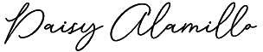
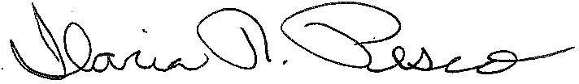
By Daisy Alamillo, ASI President

Executed on: CSU
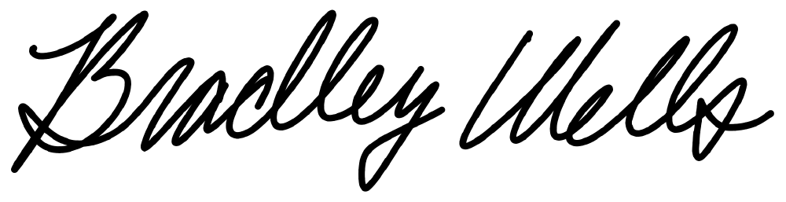
California State University Office of the Chancellor
By Brad Wells, Associate Vice Chancellor Business and Finance


Associated Students Inc. Conflict of Interest Policy
Associated Students Incorporated California State University, Bakersfield
56 SU
9001 Stockdale Highway
Bakersfield, CA 93311-1002 http://www.csub.edu/asi
(661) 654-2418
Fax (661) 654-2414

- NAME

This document shall be called the ASI Conflict of Interest Policy

- PURPOSE

This policy is in effect in order to set guidelines regarding appropriate financial interest standards for auxiliary organizations

- DATE OF EFFECTIVENESS

This policy is effective as of as approved by the ASI Board of Directors through SB.

- AMENDMENTS

This policy may be amended by a majority vote of the Internal Affairs Committee and the ASI Board of Directors.

- GUIDELINES VI.

Conflict of Interest Policy for Associated Students Board Members and Managers

Associated Students is a California Nonprofit Public Benefit Corporation whose board members are elected to serve as the official governing body of the students of California State University, Bakersfield and to advance the welfare of California State University, Bakersfield students. The board members and management staff of the organization have a duty to conduct the affairs of Associated Students, Incorporated (ASI) in a manner consistent with such purposes and not to advance their personal interests. This conflict-of-interest policy is intended to permit the organization and its board members and managers to identify, evaluate, and address any real, potential, or apparent conflicts of interest that might, in fact or in appearance, call into question their duty of undivided loyalty to Associated Students.

THE BASICS:

FULL DISCLOSURE. Board members and staff members in decision-making roles should make known their connections with groups doing business with the organization. This information should be provided at least once annually.

BOARD MEMBER ABSTENTION FROM DISCUSSION AND VOTING. Board
members who have an actual or potential conflict of interest shall not vote on matters affecting transactions between the organization and the other group.

TIMING OF DISCLOSURE: All potential conflicts must be disclosed when they occur so that board members who are voting on a decision through the legislative process are aware that another member’s interests are being affected.

MEMBER ABSTENTION

Covered Persons

This policy applies to ASI board members and managers. Each Covered Person shall be required to acknowledge, not less than annually, that he or she has read and is in compliance with this policy.

Covered Transactions
This policy applies to transactions between the ASI and a Covered Person, or between the ASI and another party with which a Covered Person has a relationship. A Covered Person is considered to have a relationship with another party if:

    - the other party is a family member, including a spouse, parent,
sibling, child, stepchild, grandparent, grandchild, great-grandchild, in-law, or domestic partner;

    - the other party is an entity in which the Covered Person has a material financial interest. This includes entities in which the Covered Person and all individuals or entities having significant relationships with the Covered Person own, in the aggregate, more than 10 percent; or

    - the Covered Person is an officer, director, trustee, partner, member, or employee of the other party.

A Covered Transaction also includes any other transaction in which there may be an actual or perceived conflict of interest, including any transaction in which the interests of a Covered Person may be seen as competing or at odds with the interests of ASI.

Disclosure, Refrain from Influence, and Recusal

When a Covered Person becomes aware of a proposed Covered Transaction, he or she has a duty to take the following actions:

    - immediately disclose in writing the existence and circumstances of such Covered Transaction to the ASI Board or Executive Director;

In order to assist ASI in identifying potential Covered Transactions, each Covered Person annually shall complete a Conflict-of-Interest Questionnaire provided by ASI, and shall update such Questionnaire as necessary to reflect changes during the course of the year. Completed Questionnaires shall be available for inspection by any board member, the ASI Executive Director and may be reviewed by ASI legal counsel.

  - Standard for Approval of Covered Transactions

Associated Students may enter into a Covered Transaction where a) such Transaction does not constitute an act of self dealing, and b) the board determines, acting without the participation or influence of the Covered Person and based on comparable market data, that such transaction is fair and reasonable to ASI. The board shall document the basis for this determination in the minutes of the meeting at which the Covered Transaction is considered, and shall consult with ASI’s legal counsel as necessary to ensure that the Transaction does not constitute an act of self-dealing.

Administration of Policy
This policy shall be administered jointly by the Board and Executive Director, which shall be responsible for the following:

    - reviewing reports regarding the Conflict-of-Interest Questionnaires

    - receiving disclosures of proposed Covered Transactions

    - reviewing proposed Covered Transactions to determine whether they meet the above-described standard

    - maintaining minutes and such other documentation as may be necessary and appropriate to document its review of Covered Transactions

    - reviewing the operation of this policy and making changes from time to time as it may deem appropriate.

Failure to Comply with Policies and Procedures

    - Board of Directors who fail to comply with policies and procedures, as prescribed above, shall be charged with an allegation of conflict of interest and be subjected to proceedings before the Executive Committee. Consequence may include removal from office.

    - ASI Staff, who fail to comply with policies and procedures, as prescribed above, may have appropriate consequences applied by the Executive Director.

Name: Date:

ASSOCIATED STUDENTS, INCORPORATED CALIFORNIA STATE UNIVERSITY, BAKERSFIELD
Conflict-of-Interest Questionnaire
Associated Students, Incorporated (ASI) requires each board member and ASI manager annually

- to review the ASI Conflict-of-Interest Policy (the “Policy”);
- to disclose any possible personal, familial, or business relationship that reasonably could give rise to a conflict of interest or the appearance of a conflict of interest; and
- to acknowledge by his or her signature that he or she is acting in accordance with the letter and spirit of such Policy.
The information provided on this form shall be available for inspection by members of the Board, the ASI Executive Director, and ASI’s legal counsel, but shall otherwise be held in confidence except when, after consultation with the applicable board member or ASI manager, the Board determines that ASI’s best interest would be served by disclosure.
Please respond to the following questions to the best of your knowledge. *

- Please list all businesses, corporations, partnerships, associations, departments, clubs, or other organizations of which you are an officer, director, trustee, partner, member, or employee, and describe your affiliation with such entity.

- Please list all entities above in which you have a material financial interest as defined in the Policy.

- Please list all business dealings that you, your family members, and/or entities listed in paragraphs 1 – 2 above have had with ASI in the past year.

- Please list any proposed business dealings between ASI and you, your family members, and/or entities listed in paragraphs 1 – 2 above. Describe each such relationship listed and the actual and potential benefits as you can best estimate them.

- Are you aware of any other relationships, arrangements, transactions, or matters which could create a conflict of interest or the appearance of conflict? If so, please describe.

I have received and read the Associated Students, Incorporated Conflict-of-Interest Policy. I am currently, and agree to remain, in compliance with the Policy.

Signature Date

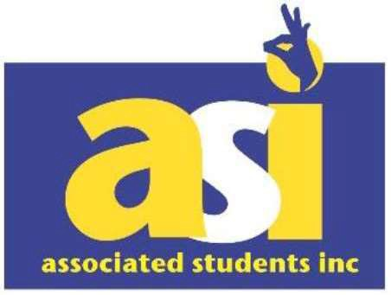
Associated Students Incorporated California State University, Bakersfield
56 SU
9001 Stockdale Highway
Bakersfield, CA 93301-1002 http://www.csub.edu/asi

(661) 654-2418
Fax (661) 654-2414

Attachment 2:

Operating Agreement: California State University and Associated Students California State University, Bakersfield, Incorporated

Item 6.

Associated Students, Inc. did not expend funds for public relations or other purposes to augment appropriations for CSU operations.

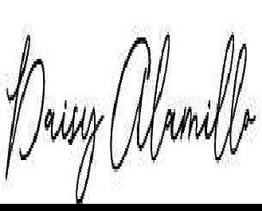
Daisy Alamillo, President

06/05/2023

Date

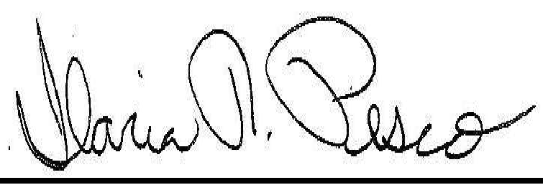
Ilaria R. Pesco, Executive Director

06/05/2023

Date

It's Your Student Government

A0745949

FILED H" /.
Secretary of State //
State of California ,, f.Pf!r.1

Attachment 3
\ c:c SEP 1 3 2013

RESTATED
ARTICLES OF INCORPORATION OF ASSOCIATED STUDENTS,
CALIFORNIA STATE UNIVERSITY, BAKERSFIELD, INC.

Hilda Nieblas and Taren Mulhause certify that:

- They are the President and Secretary, respectively, of Associated Students, California State University, Bakersfield, Inc.
- The following amended and restated Articles of Incorporation of this corporation has been approved by the board of directors:
ARTICLE I
Name

The name of this corporation is:

ASSOCIATED STUDENTS, CALIFORNIA STATE UNIVERSITY, BAKERSFIELD, INC.

ARTICLE II
Corporate Status

This corporation is a nonprofit public benefit corporation and is not organized for the private gain of any person. It is organized under the Nonprofit Public Benefit Corporation Law for public purposes.
ARTICLE III
Purposes

This Corporation is organized and operated solely for the benefit of California State University, Bakersfield. This corporation is organized as a student body organization under Section 89300, et seq. of the California Education Code, exclusively for educational and charitable purposes within the

A07lJ5949

meaning of Section 501(c)(3) of the Internal Revenue Code of 1986 as amended and for the following purposes:
  - To operate exclusively for public and charitable purposes within the meaning of the California Revenue and Taxation Code Section 23701d (or corresponding provisions of any future California Revenue Law).

  - Subject to the direction and approval of the University President or designee, to develop, manage and oversee campus programs at California State University, Bakersfield, for the benefit of students, faculty, staff, and alumni in order to promote and assist the educational program of the University operating as an integrated part of the overall University campus program, and to apply the funds and properties coming into its control toward furthering the educational mission of the University.
  - To provide student leadership, self-governance, and civie and cultural development opportunities as the Board of Directors and members of this corporation may find or consider to be suited to the primary purpose of advancing the welfare of California State University, Bakersfield, and for promoting the common educational interests of California State University, Bakersfield students, as approved by the University President or a designee.

  - To do or refrain from doing any lawful act or thing which at anytime may be authorized by the Board of Directors or members of this corporation, so long as the doing or refraining from doing the lawful act will advance the welfare of California State University, Bakersfield, and promote the common educational interests of California State University, Bakersfield students.

(e) To provide service and support to the students of California State University, Bakersfield.

This corporation is formed, and shall operate California State University, Bakersfield in Internal Revenue Code Section 509(a)(3).
exclusively the accordance with

ARTICLE IV
Conformity with Law

The corporation shall be an auxiliary organization to California State University, Bakersfield, and shall conduct its operations in conformity with the California statutes governing such organizations (Chapter 7, commencing with Section 89900, of Part 55, Division 8, Title 3 of the Education Code) and the Regulations adopted by the Board of Trustees of California State University (Subchapter 6, commencing with Section 42400, of Chapter 1, Division 5 of Title 5 of the California Code of Regulations) as required by the Education Code, Section 89900(c).
ARTICLE V
Exempt Status

No part of the net earnings of this corporation shall inure to the benefit of or be distributable to its members, directors, officers, or other private persons, except that this corporation shall be authorized and empowered to pay reasonable compensation for services rendered and to make payments and distributions in furtherance of the purposes set forth in Article III hereof.

ARTICLE VI
Limitation on Activities

No substantial part of the activities of this corporation shall be the carrying on of propaganda, or otherwise attempting to influence legislation, and this corporation shall not participate in, or intervene in (including the publishing or distribution of statements) any political campaign on behalf of any candidate for public office.

ARTICLE VII
Irrevocable Dedication and Dissolution

This corporation irrevocably dedicates its assets for the benefit California State University, Bakersfield. Upon the dissolution of this corporation, net assets other than trust funds shall be distributed for one or more exempt purposes within the meaning of section 501(c)(3) of the Internal Revenue

Code (or corresponding section of any future federal tax code) or to a government for public purposes, as approved by the Board of Directors, the President of California State University, Bakersfield and by the Chancellor of the California State University. Trust funds shall be distributed consistent with the terms of the trust instruments and section SOl (c)(3) of the Internal Revenue Code (or corresponding section of any future federal tax code).

ARTICLE VIII
Officers and Directors

The Officers and number of Directors, their qualifications, powers, duties, terms of office, manner of election, removal and filling vacancies on the Board, and the manner of calling and holding meetings of the Board, shall be as stated in the Bylaws.

ARTICLE IX
Members

This corporation shall have no members other than the persons constituting its Board of Directors. The Board of Directors shall, under any statute or rule of law, be the members of this corporation and shall have all the rights and powers members would otherwise have.

ARTICLE X
Voting

Each member of the Board of Directors shall have one vote. There shall be no proxy voting permitted for the transaction of any of the business of this corporation.

ARTICLE XI
Amendment

The Articles of Incorporation of this corporation may be amended by resolution of the Board of Directors and approved by the President, California State University, Bakersfield.

- The foregoing restated Articles of Incorporation, has been approved by a resolution duly adopted by the Board of Directors and approved by the University President, as required by Article XI.
- The corporation has no members other than the persons constituting its Board of Directors.

Verification

Each of the undersigned declares under penalty of perjury under the laws of the State of California that the statements in the foregoing certificate are true and correct of his or her own knowledge, and that this declaration was executed on the date below at Bakersfield, California.



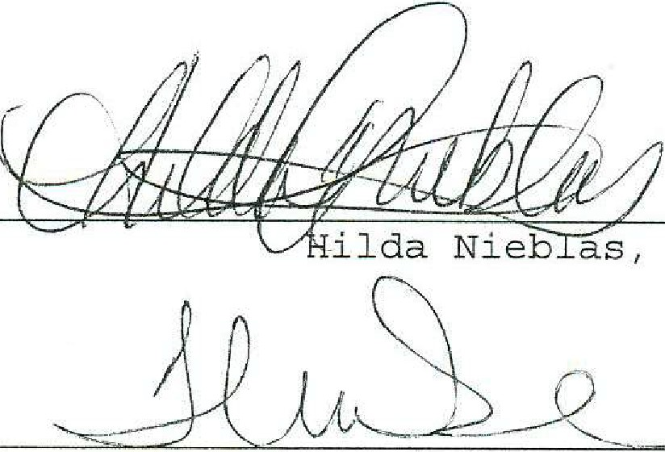
President

Taren Mulhause, Secretary

Approved:

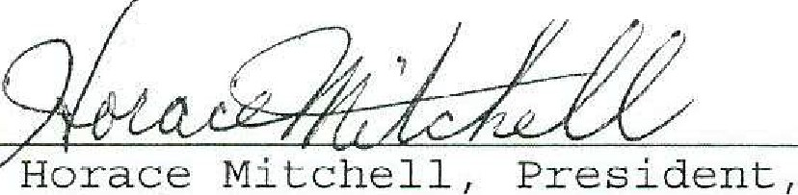
8/J 2/;3
)

Dr CSU Bakersfield Da'te L



CSUB ASI Operating Agreement COA1468
2023-2030
Final Audit Report 2023-06-28
Created:
2023-06-14
By:
Marina Manzano (mmanzano@csub.edu)
Status:
Signed
Transaction ID:
CBJCHBCAABAA2gtzlJDnGB2UqlYMdNyM2JQniqi-p1OZ

"CSUB ASI Operating Agreement COA1468 2023-2030" History
Document created by Marina Manzano (mmanzano@csub.edu)
2023-06-14- 9:33:47 PM GMT- IP address: 136.168.107.84

Document emailed to Daisy Alamillo (dalamillo1@csub.edu) for signature
2023-06-14 - 9:40:02 PM GMT

Email viewed by Daisy Alamillo (dalamillo1@csub.edu)
2023-06-14-10:07:50 PM GMT- IP address: 198.189.249.68

Document e-signed by Daisy Alamillo (dalamillo1@csub.edu)
Signature Date: 2023-06-14 - 10:10:11 PM GMT - Time Source: server- IP address: 198.189.249.68

Document emailed to Ilaria Pesco (ipesco@csub.edu) for signature
2023-06-14 - 10:10:12 PM GMT

Email viewed by Ilaria Pesco (ipesco@csub.edu)
2023-06-15-10:47:16 PM GMT- IP address: 136.168.153.17

Email viewed by Ilaria Pesco (ipesco@csub.edu)
2023-06-26- 6:06:43 PM GMT- IP address: 136.168.153.17

Document e-signed by Ilaria Pesco (ipesco@csub.edu)
Signature Date: 2023-06-26 - 6:06:53 PM GMT - Time Source: server- IP address: 136.168.153.17

Document emailed to Thom Davis (tdavis31@csub.edu) for signature
2023-06-26 - 6:06:55 PM GMT

Email viewed by Thom Davis (tdavis31@csub.edu)
2023-06-27 - 2:55:37 AM GMT- IP address: 172.226.7.13



Document e-signed by Thom Davis (tdavis31@csub.edu)
Signature Date: 2023-06-28 - 11:12:08 PM GMT - Time Source: server- IP address: 136.168.243.150

Agreement completed.
2023-06-28 - 11:12:08 PM GMT

