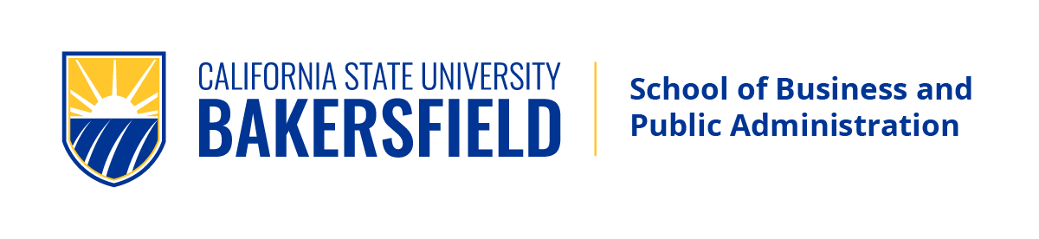
Spring 2022 Guest Speakers

Department of Public Policy & Administration

“Public policy issues impacting our community:
leadership in decision-making”

Bringing Community Leaders into the Classroom
Bringing community leaders into the classroom is an opportunity for students to meet, interact, network, and discuss real world policy and administrative issues.

Students, you are invited to sit-in via Zoom
This semester, in Dr. Thomas Martinez’ course PPA 6530 Public Policy Analysis
the following community leaders will guest speak.


Mr. Louis Gill
Executive Director (ret.), Bakersfield Homeless Center,
5:45-7pm, Tuesday, March 15, 2022
Join Zoom Meeting https://csub.zoom.us/j/84407778034?pwd=SWs3NjJXWVp1TjZXSXZmbzhka1liQT09

Meeting ID: 844 0777 8034 Passcode: 700845

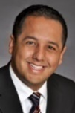
Mr. Andrae Gonzales
Ward 2 City Councilman, City of Bakersfield,
5:45-7pm, Tuesday, March 22, 2022
Join Zoom Meeting https://csub.zoom.us/j/83710505874?pwd=aVIyNXJYRjFRUFg0OWEzVnhCM0xJQT09
Meeting ID: 837 1050 5874 Passcode: 554823


Ms. Leticia Perez
5th District Supervisor, County of Kern
5:45-7pm, Tuesday, April 26, 2022
Join Zoom Meeting https://csub.zoom.us/j/82433501172?pwd=VG4vb2R4NG9JbDlGWENmRTdwVUl6QT09
Meeting ID: 824 3350 1172 Passcode: 268772

Questions, Bios & More Information Contact:
Thomas R. Martinez, Ph.D., Professor & MPA Director
C: 661-549-5923 tmartinez@csub.edu

Undergrads, Become Part of the Action!
Undergrads, if you are not already, you can become part of the PPA action. Here are some options:

- BA PA - Bachelor of Arts, Public Administration.
- BS PA - Public Administration Concentration in the B.S. in Business.
- Minor in Public Administration, or,
- “FAST TRACK” to the MPA, take up to 2 MPA Foundation courses as a senior

To learn more: PPA: 661-654-2197 https://bpa.csub.edu/

MPA Application Deadline Dates
- If interested in the MPA for Fall ’22 admission,
apply by: June 03, 2022.
- Spring ’23 application period is:
Aug. 1, 2022 - Nov. 03, 2022
Apply to the CSU online at Cal State Apply: https://www2.calstate.edu/Apply

For application assistance contact:
Mr. Luis Hernandez, BPA Graduate Office
O: 661-654-2780 MPA@csub.edu

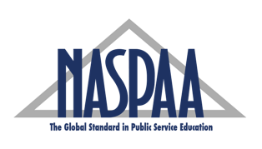
Network of Schools of Public Policy, Affairs, and Administration

“When it comes to your education, quality matters!”

